**N.AYYAPPA KUMAR(16157522)**

**KDM LAB-3**

In order to complete the tasks assigned in lab-3 assignment first of all download the cloudera image from the provided URL In addition to this Install VMware in your systems. below figure represents the installation process of VMware.

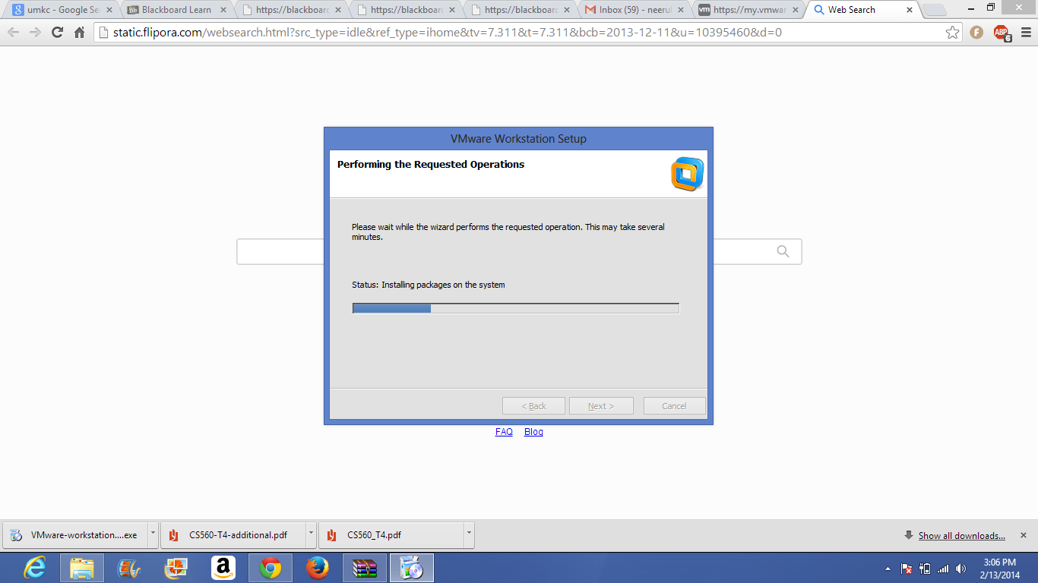

Then open the cloudera image in VMware.

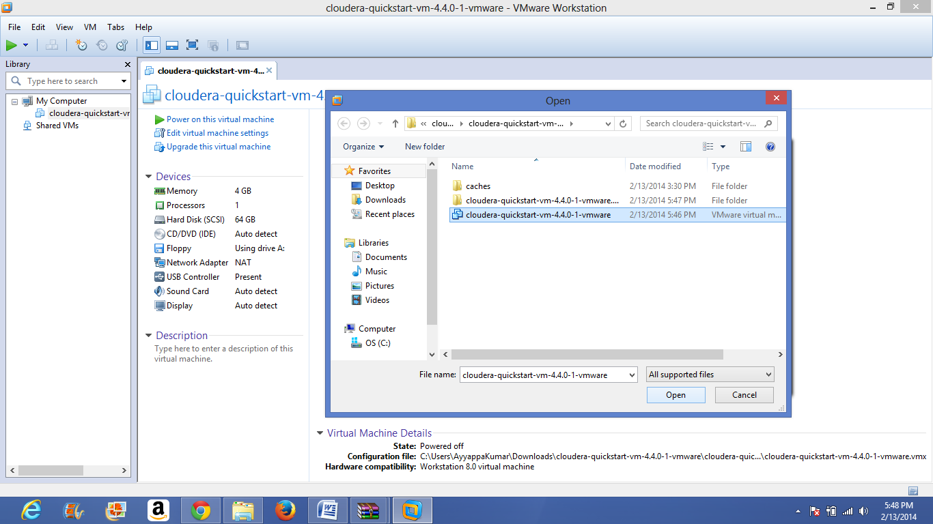

After opening the machine click on power on this virtual machine. Mean While you have to use the login details like username and password as cloudera.

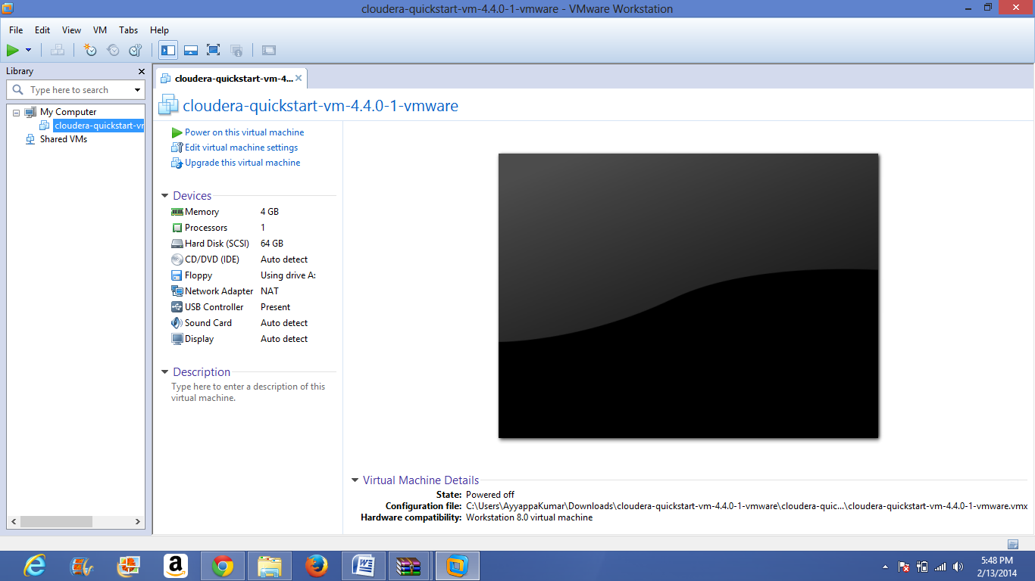

Then the image gets initialized as shown in below following two figures.

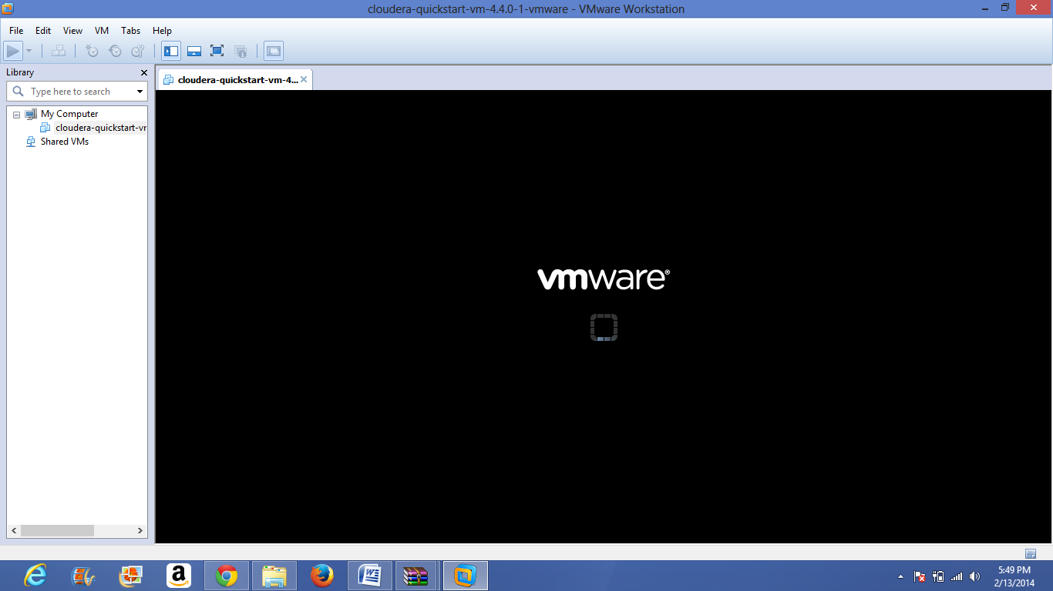

There are some features already initialized in firefox , you can see them in below figure.

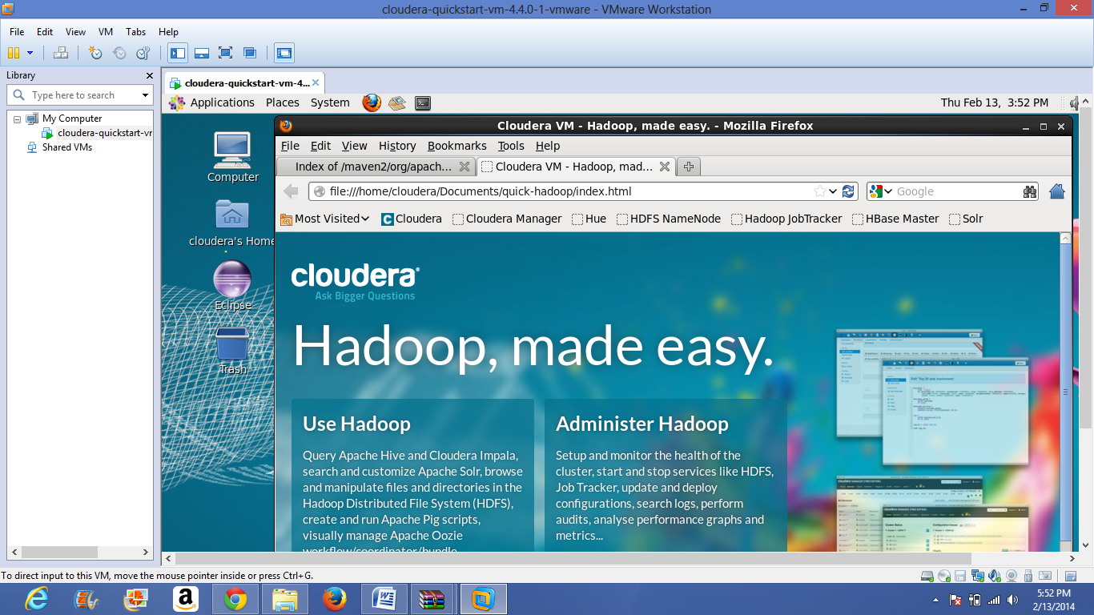

Then click on any any option like cloudera, cloudera manager etc.

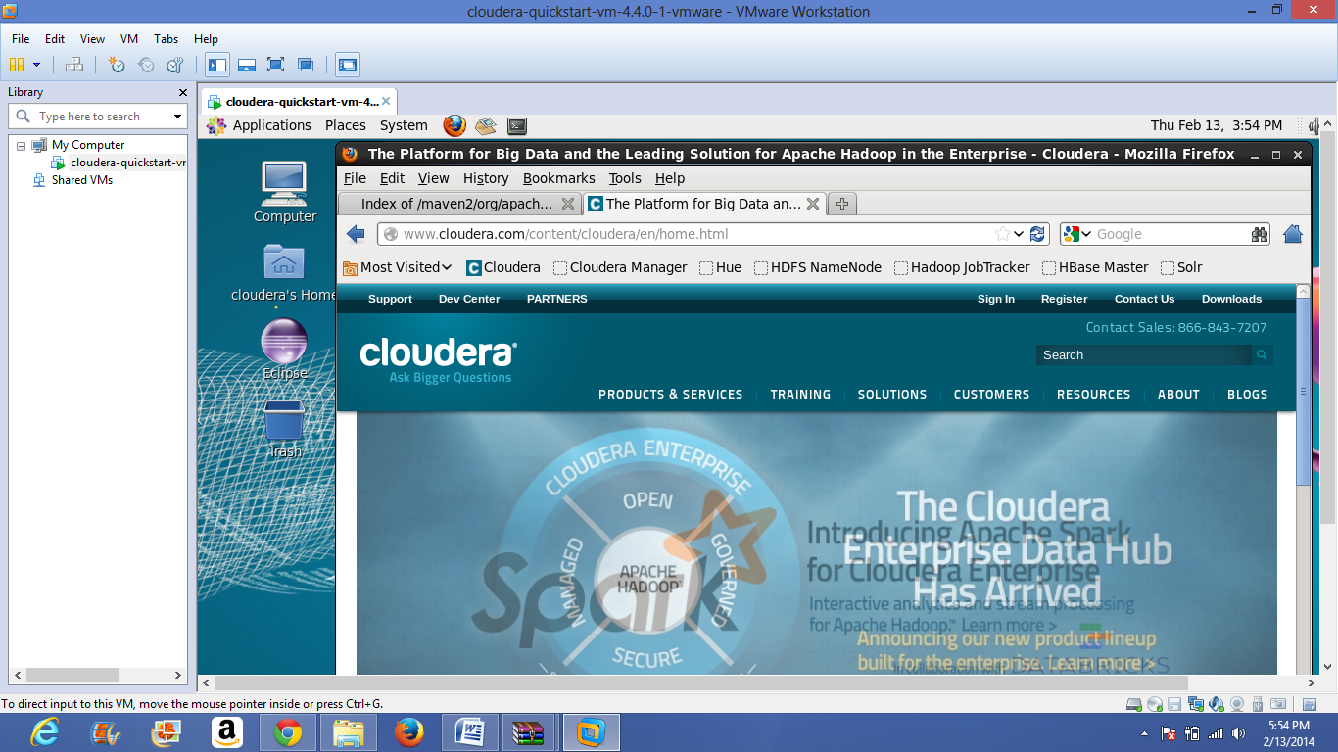

you have to login into cloudera by using both username and password as cloudera.

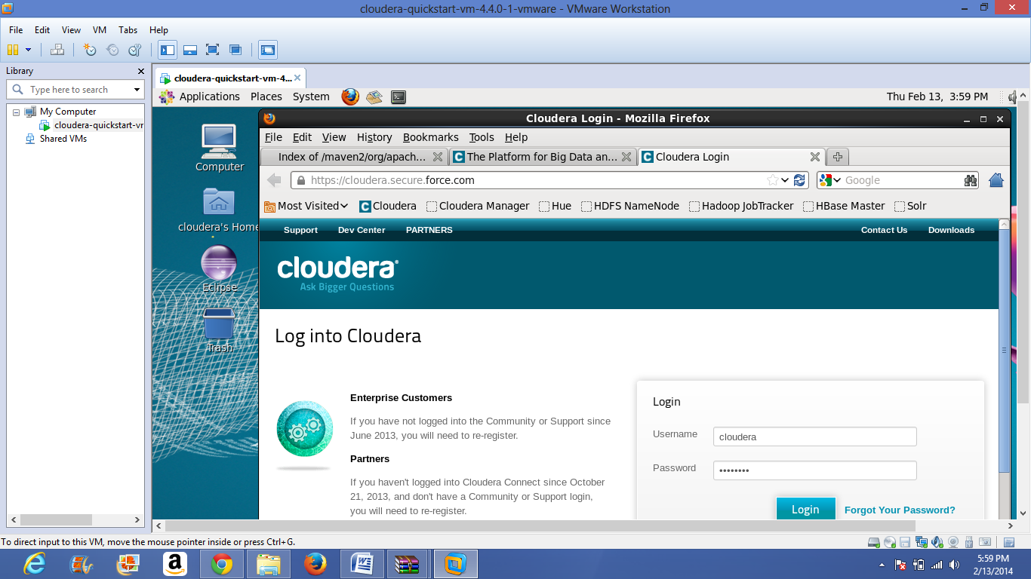

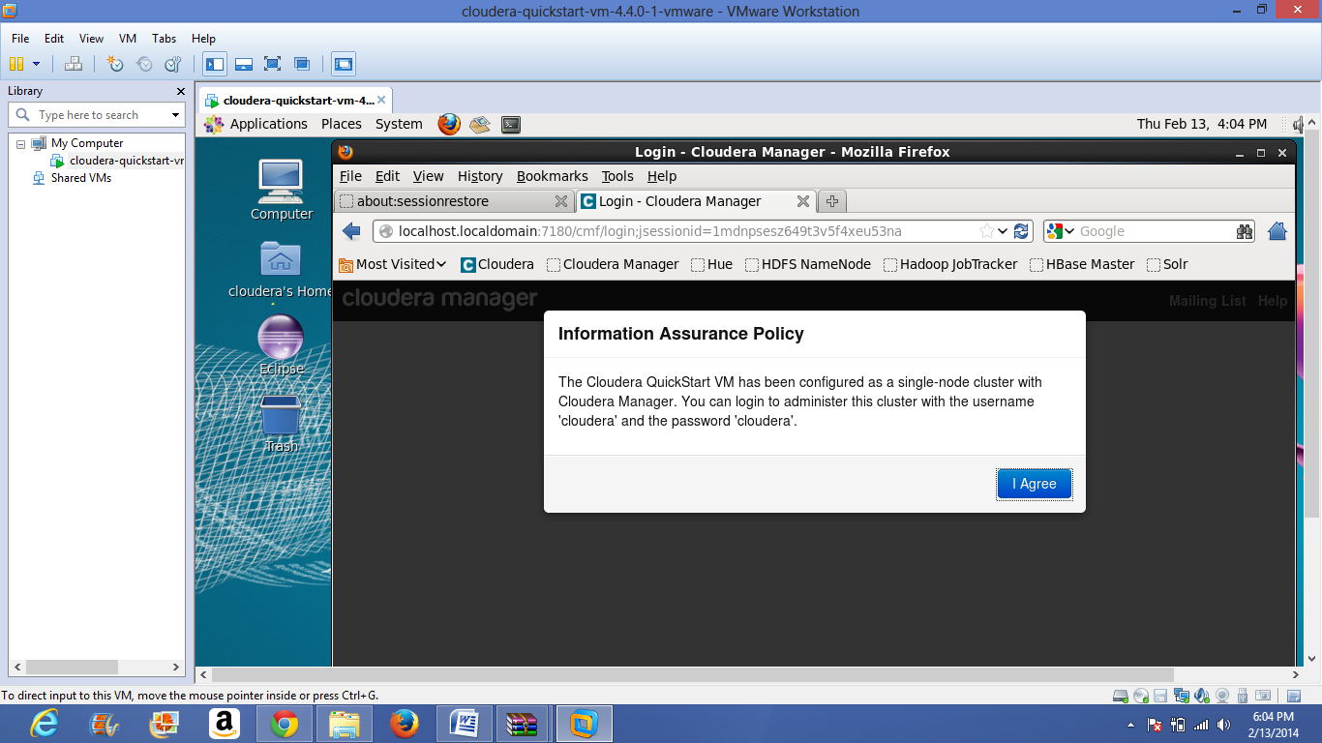

For cloudera manager also use both username and password as cloudera.

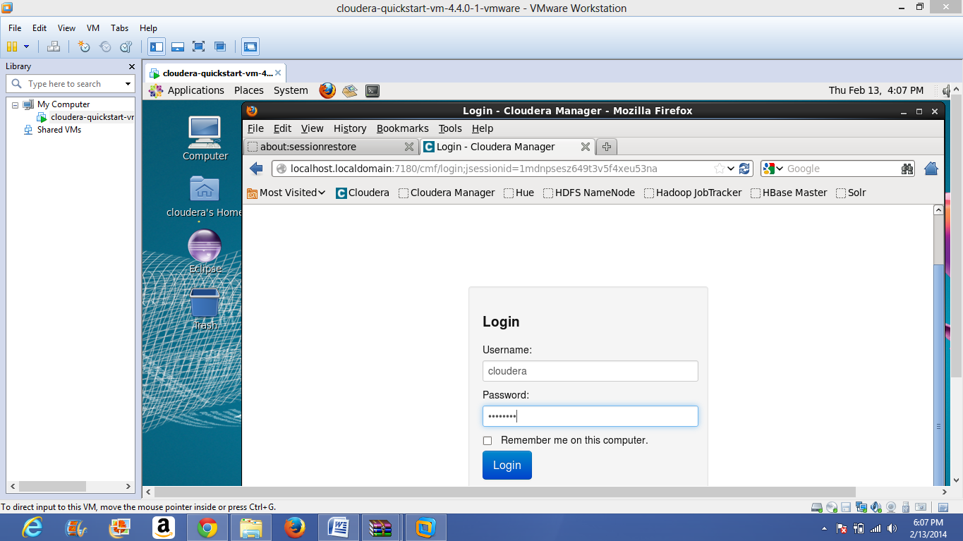

Then download word count example from the link https://portal.futuregrid.org/manual/hadoop-wordcount in firefox.

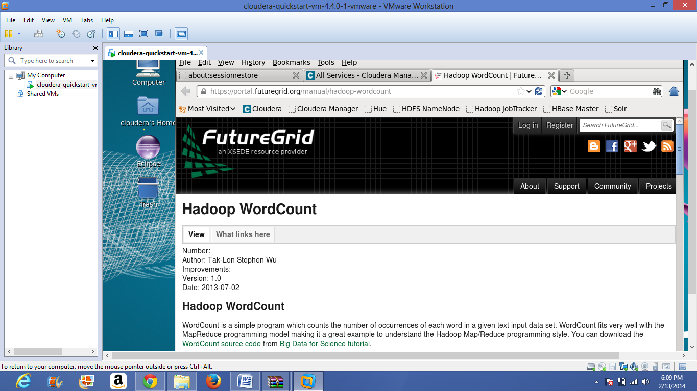

then the download completion of word count example is shown in below figure.

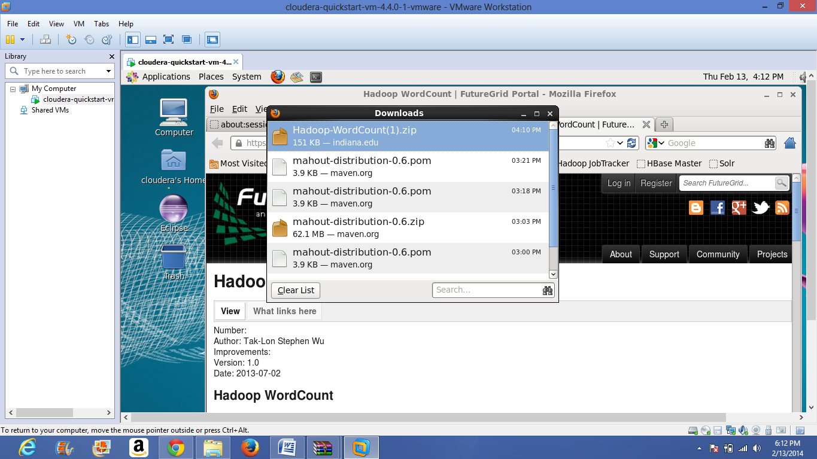

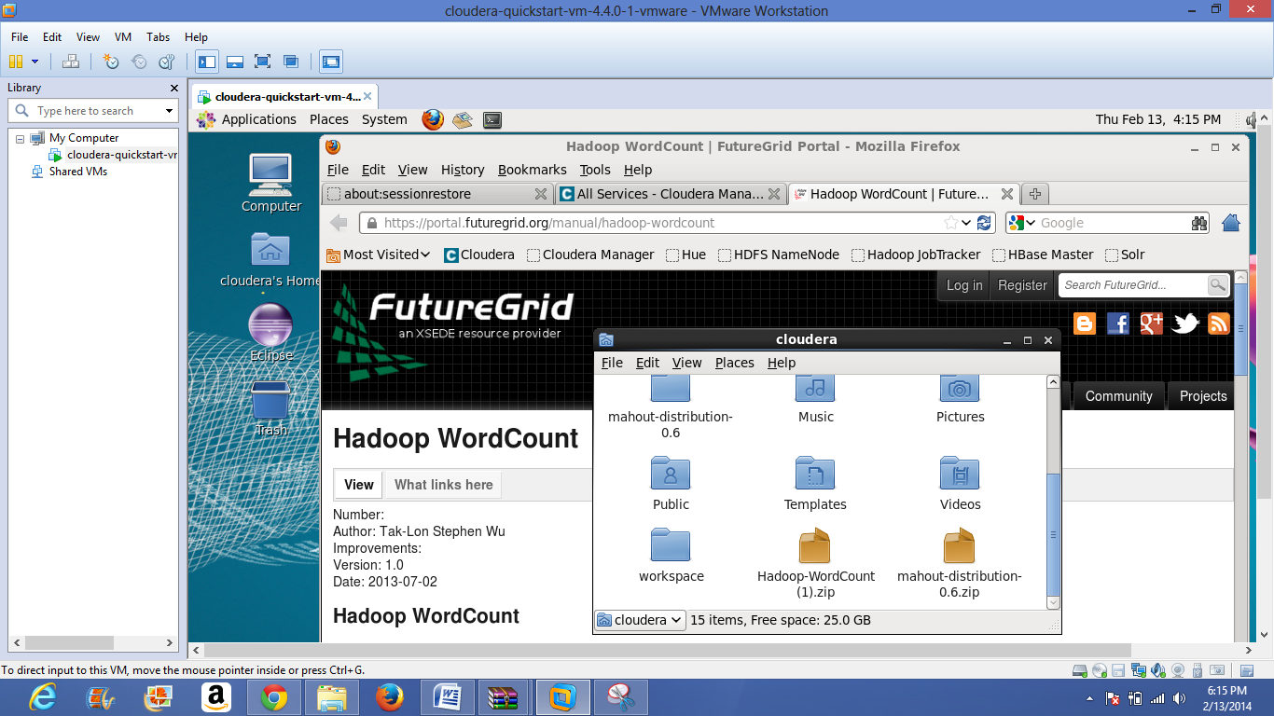

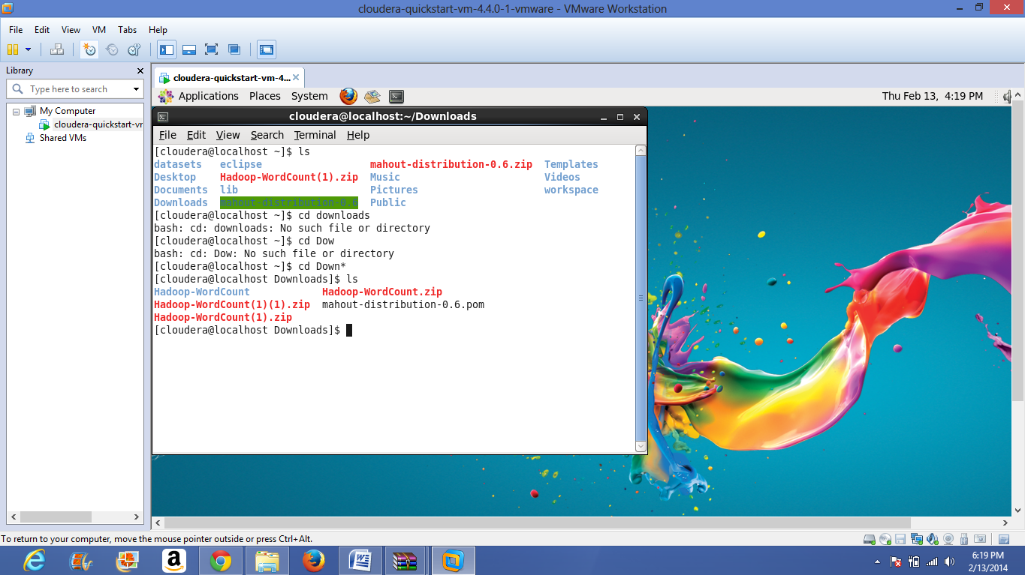

Then unzip the wordcount.zip and go to word count folder for this use command like cd wordcount.

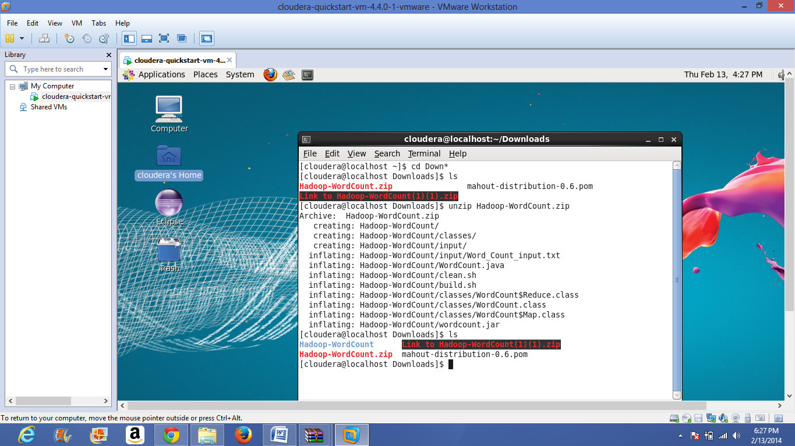

Then apply the commands

hadoop fs -put input input hadoop jar wordcount.jar WordCount input output3

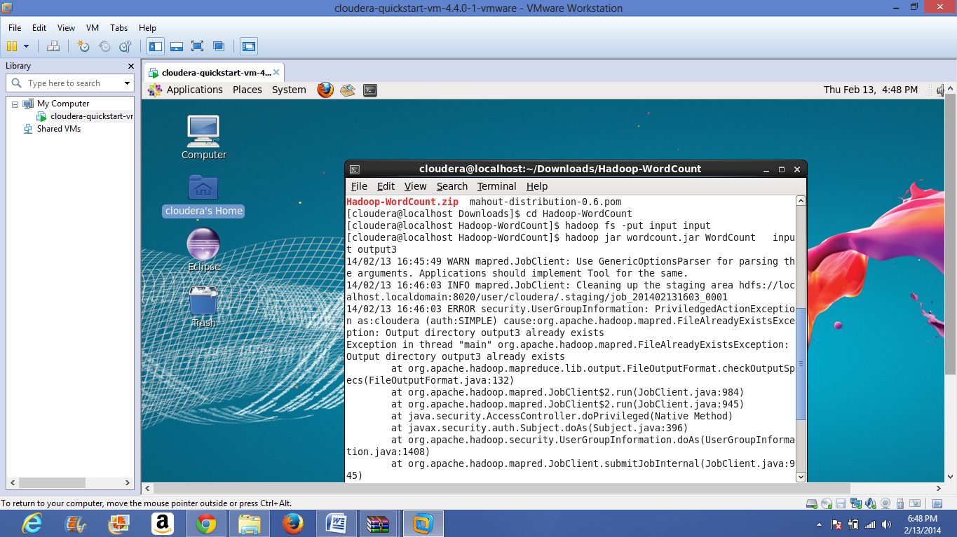

view the result from output3 by using command hadoop fs -cat output3/*

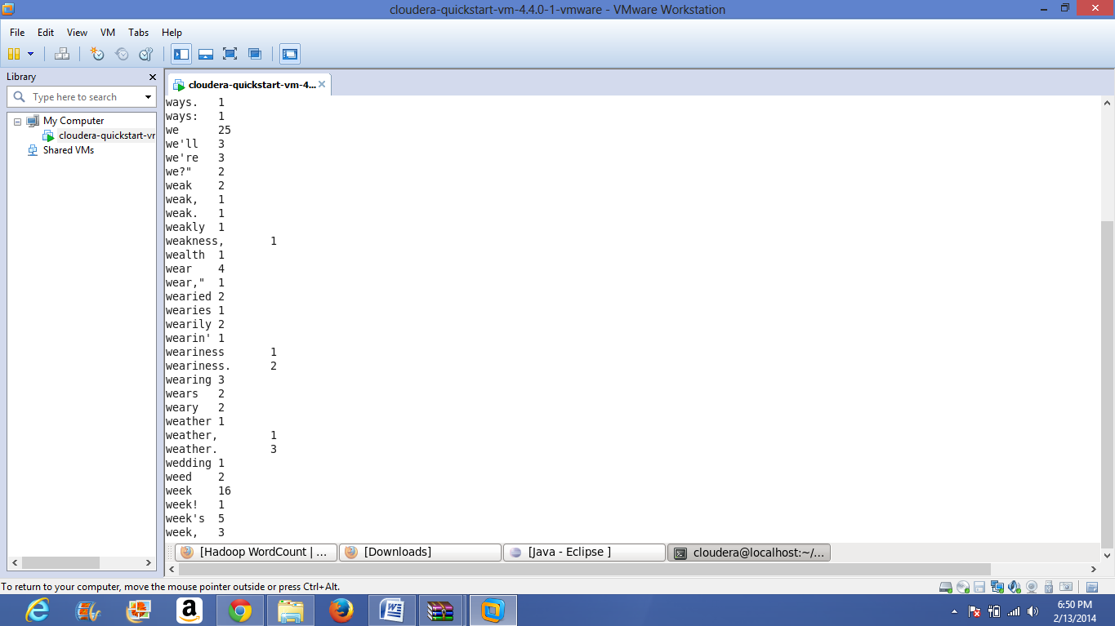

**Install Mahout:**

Download Maven 3.0.5 by using wget http://www.apache.org/dist//maven/binaries/apache-maven-3.0.5-bin.tar.gz command

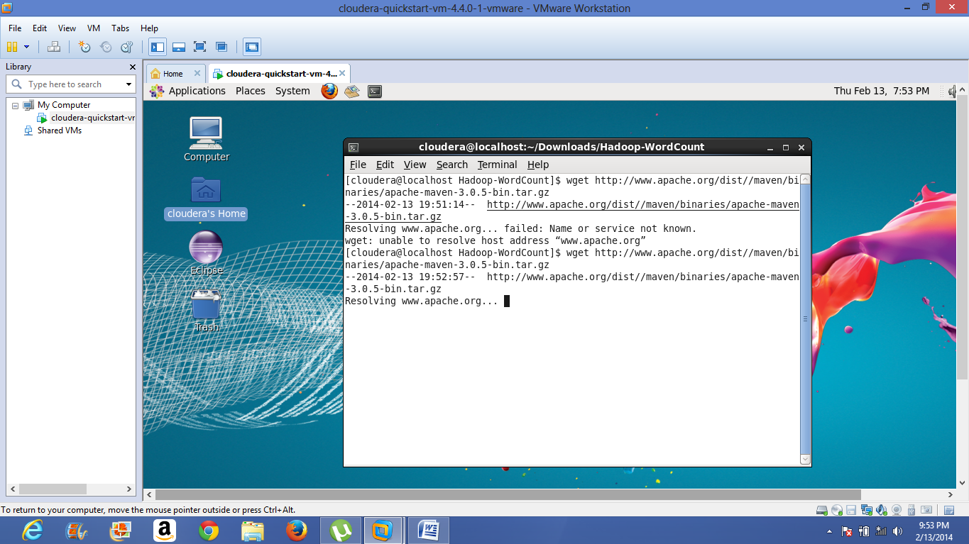

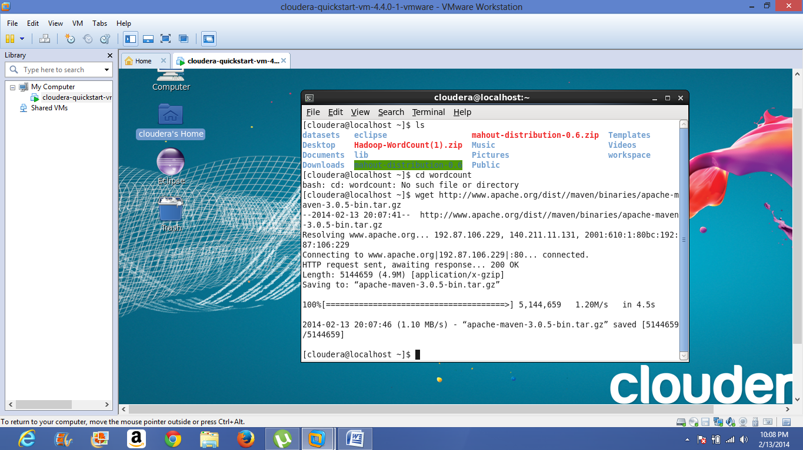

Extract archive

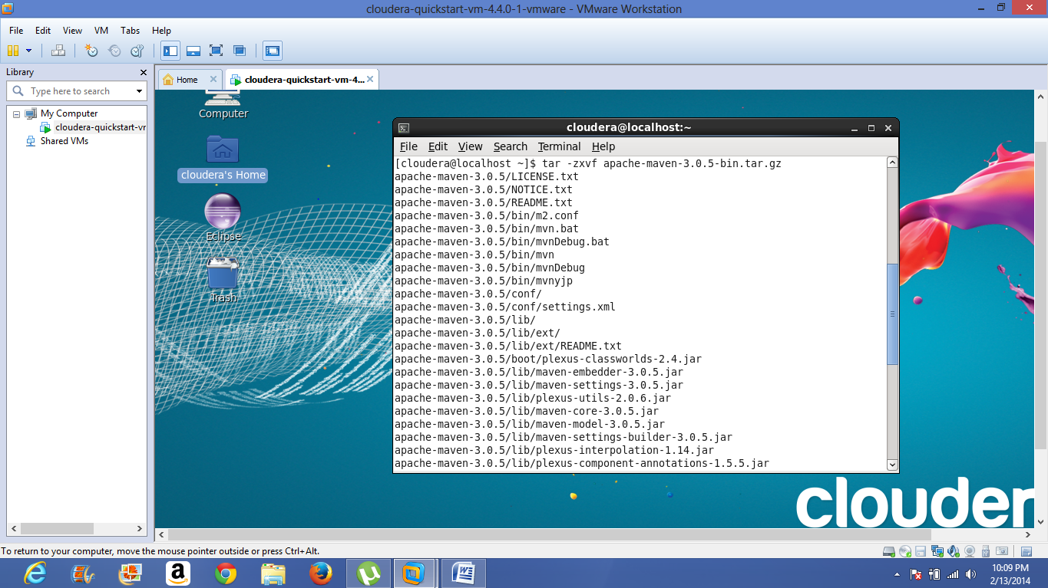

Here we have to add M2_HOME and PATH. And then check maven version by using mvn -version.

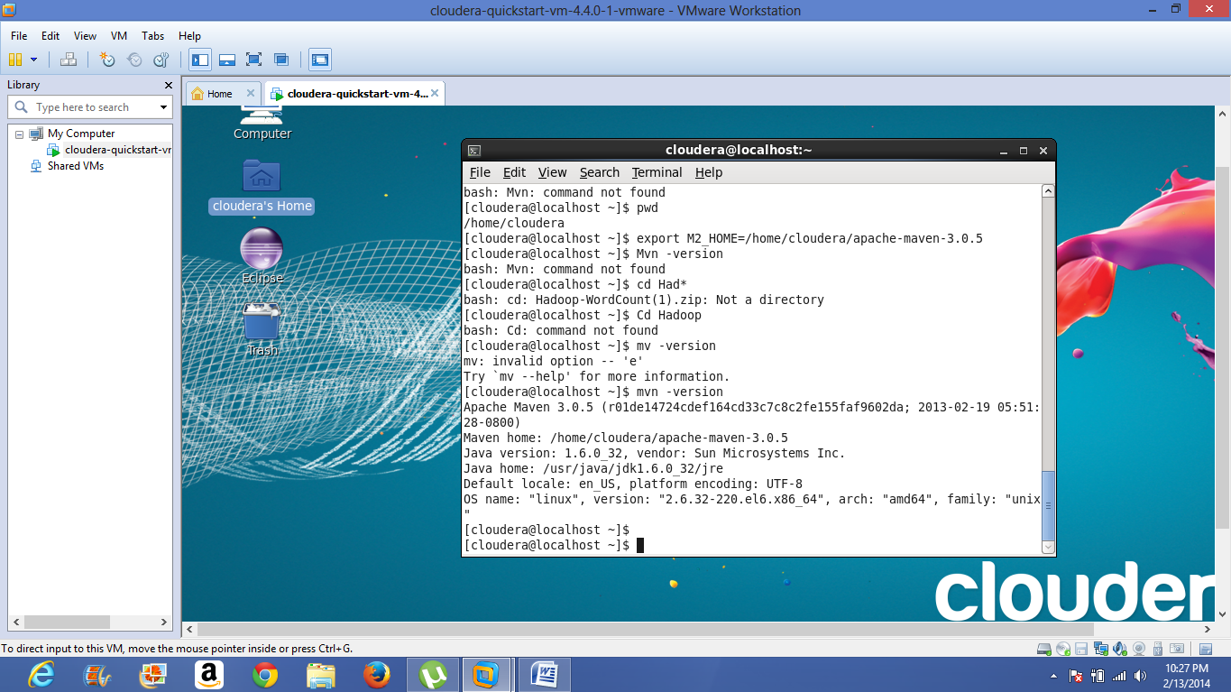

download mahout0.6, both mahout-distribution-0.6.pom as well as mahout-distribution-0.6-zip

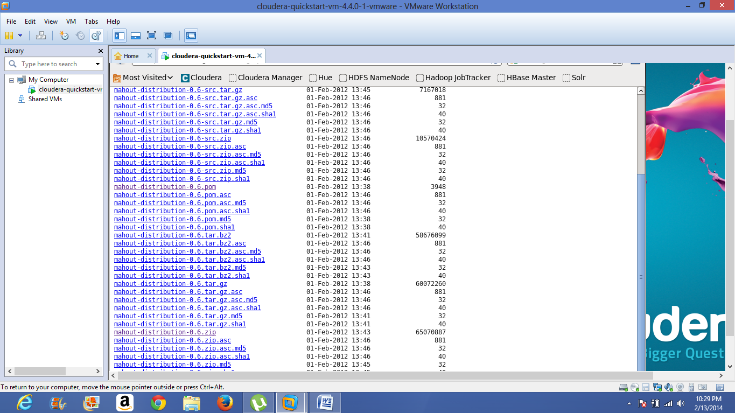

unzip the zip file and go to mahout-distribution-0.6. then move the pom file to mahout-distribution-0.6

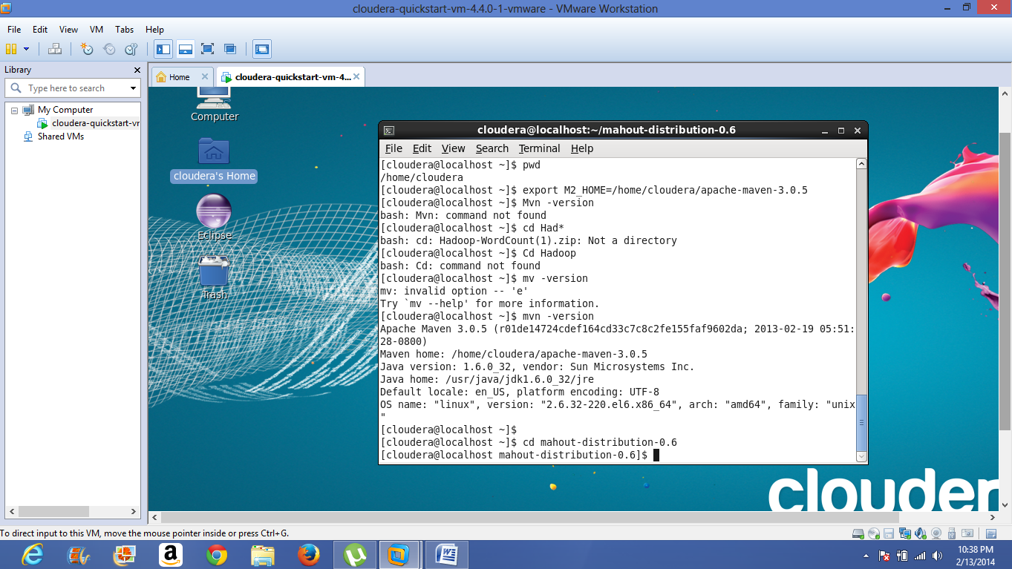

install mahout using pom by maven using the command mvn -f mahout-distribution-0.6.pom-DskipTestsinstall.

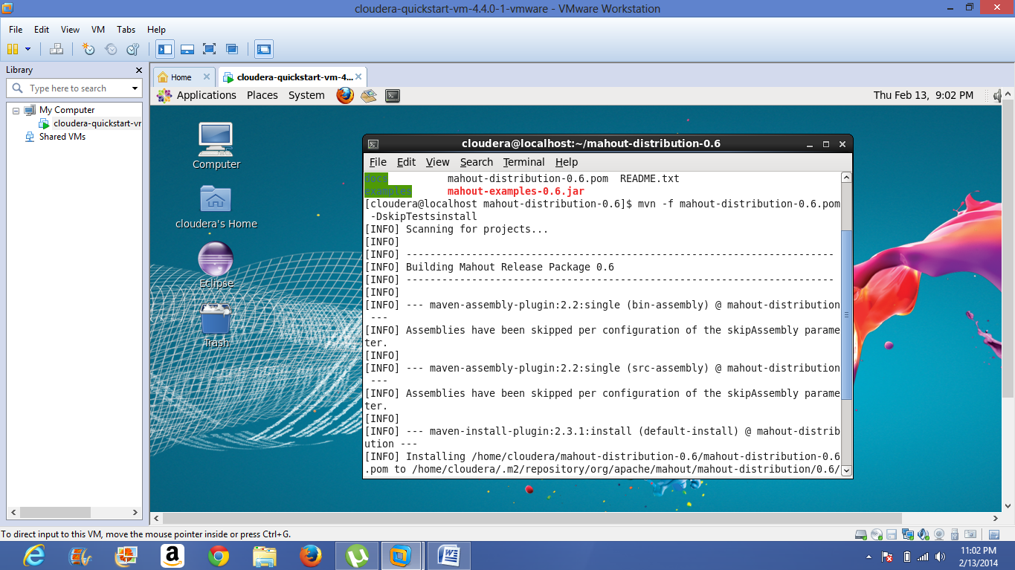

installation continues.

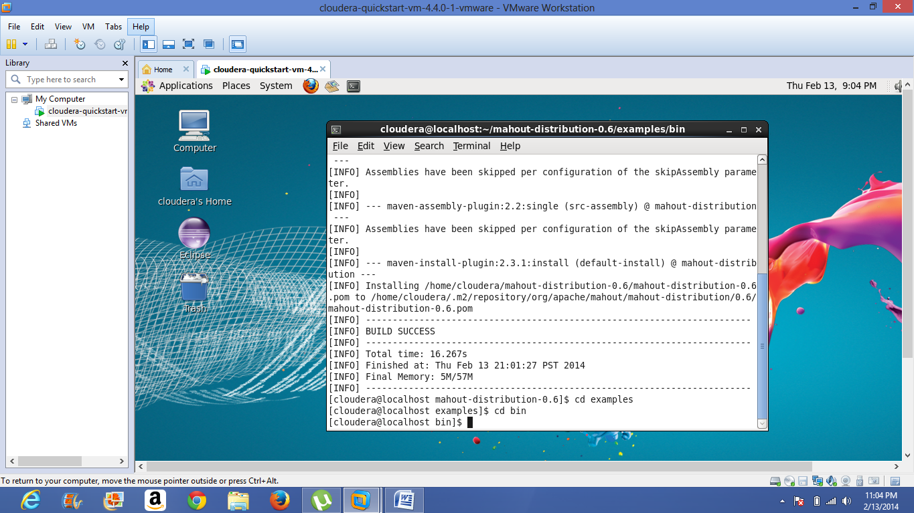

After installation go to examples then go to bin then implement the command ./classify-20newsgroup.sh

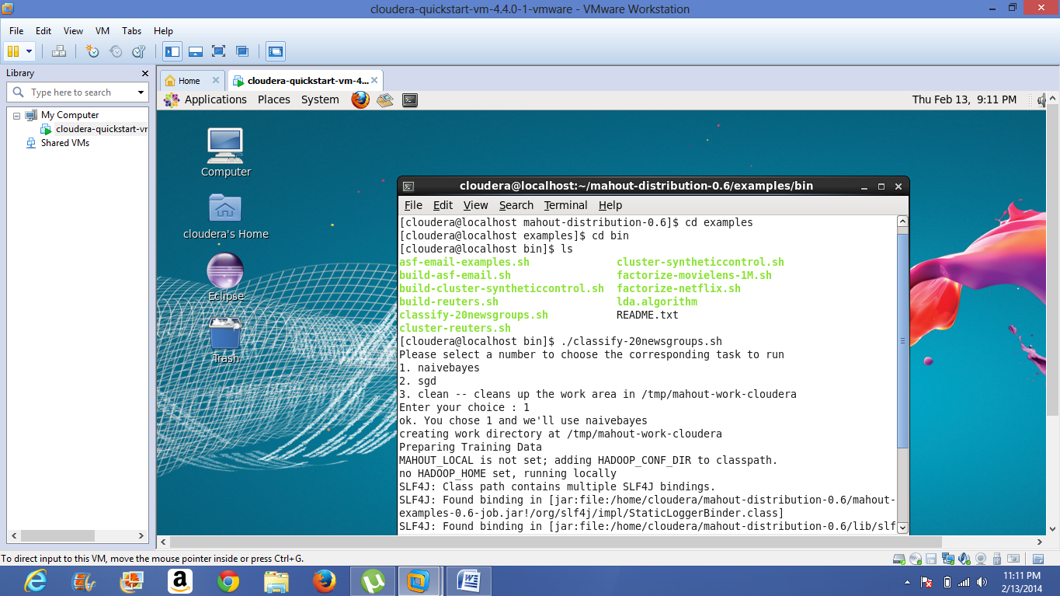

Then output can be shown as below.

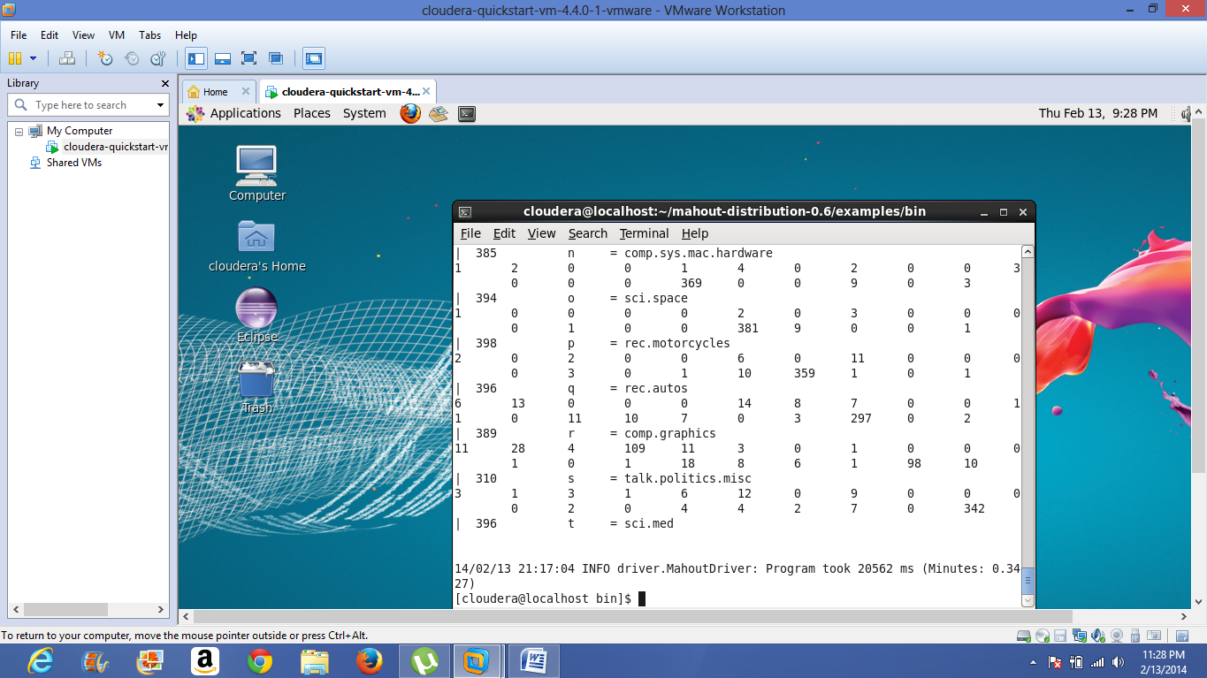

**MASH-UP application**

1. In order to develop the Mash-up application I choose JSFiddle.net

2. My intention is to develop an application in such a manner which provides the direction from one place to another place by means of four different ways of transportation, they are driving, walking, bicycling, transit. And it also provides the user to share that application on social sites.

3. In order to develop this application, I used Google Map APIs as well as openweathermap.org API

4. In this application I created a Jquery ready function for id: "control".

So this control block initializes the map whenever it is loaded

$('#control').ready(function() {

initialize(41.850033, -87.6500523);

5. Here the user has to give the source and destination information in order to get the travelling directions between them, after that user has to click on submit button then route is calculated using calcRoute() function.

6. Then the direction between two places is displayed and the present weather conditions of those places are also be displayed.

7. Here sharing the application on social sites is also be enabled.

Jsfiddle link for the application: <http://jsfiddle.net/an5kc/zDgRP/21/>

Developed mobile web application display .

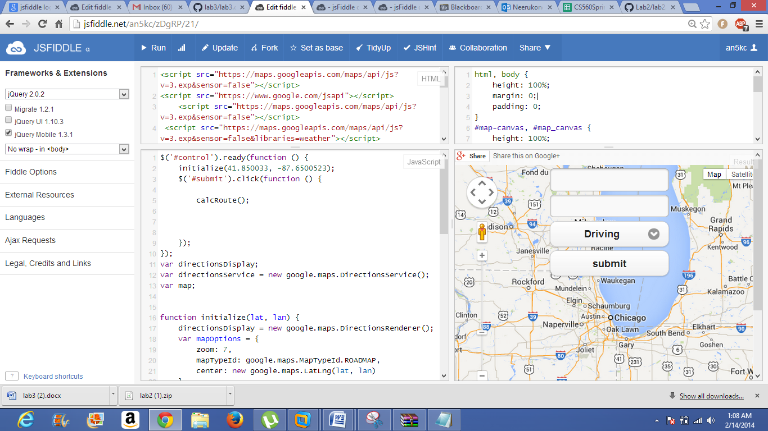

below is screen shot that represents the user wants to go to Missouri(rolla) from Kansas city and he chosen the type of transportation as driving and the direction from source to destination is displayed.

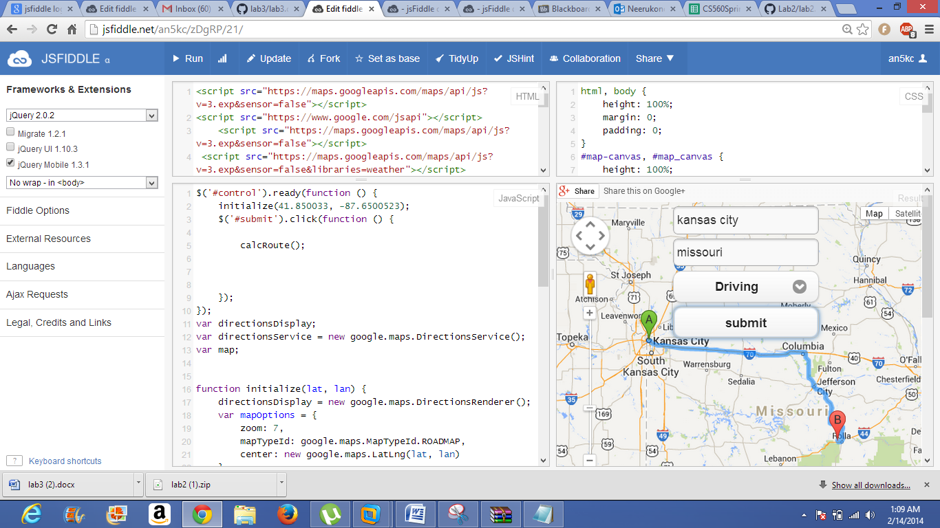

below is screen shot that represents the user wants to go to Missouri(rolla) from Kansas city and he chosen the type of transportation as walking and the direction from source to destination is displayed.

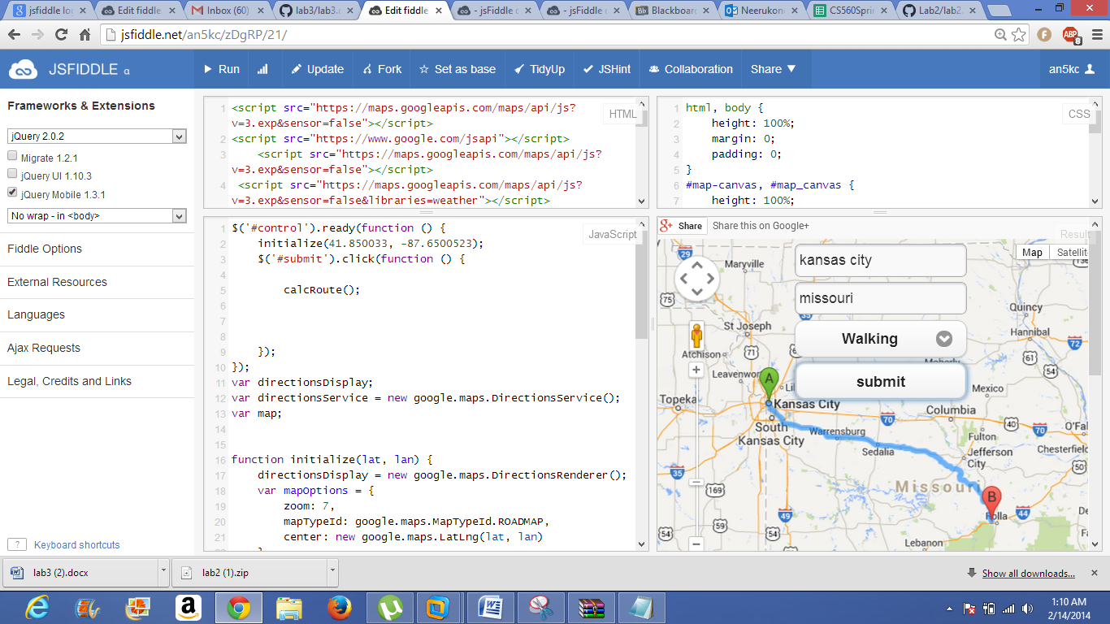

below is screen shot that represents the user wants to go to Missouri(rolla) from Kansas city and he chosen the type of transportation as transit and the direction from source to destination is displayed.

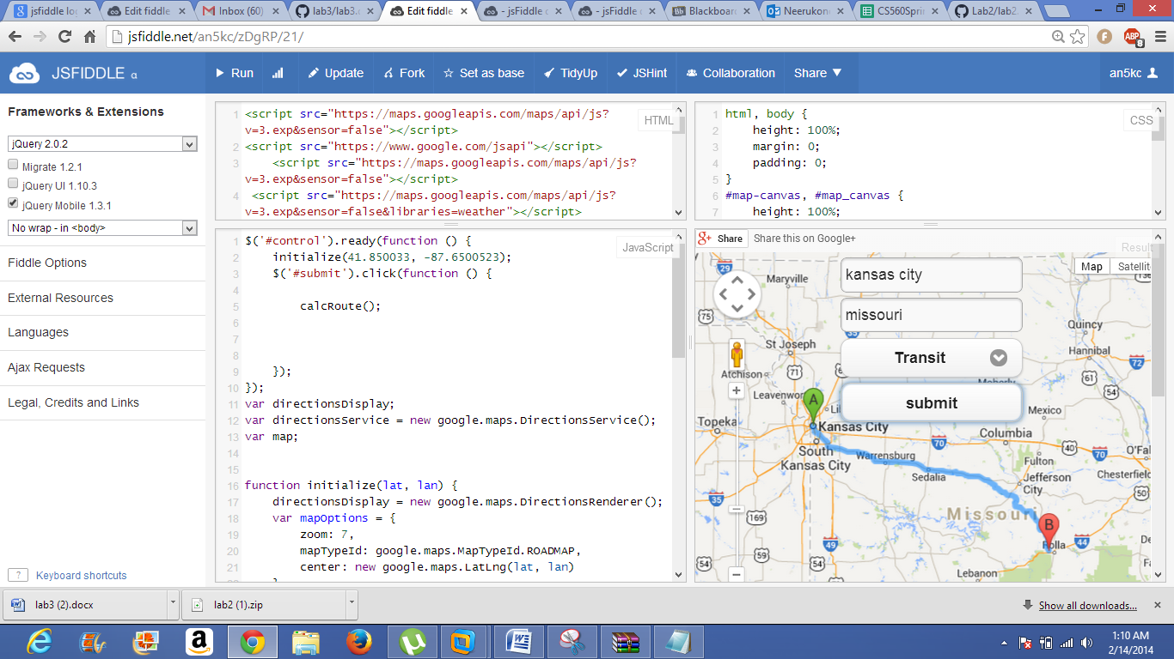

below is screen shot that represents the user wants to go to Missouri(rolla) from Kansas city and he chosen the type of transportation as bicycling and the direction from source to destination is displayed.

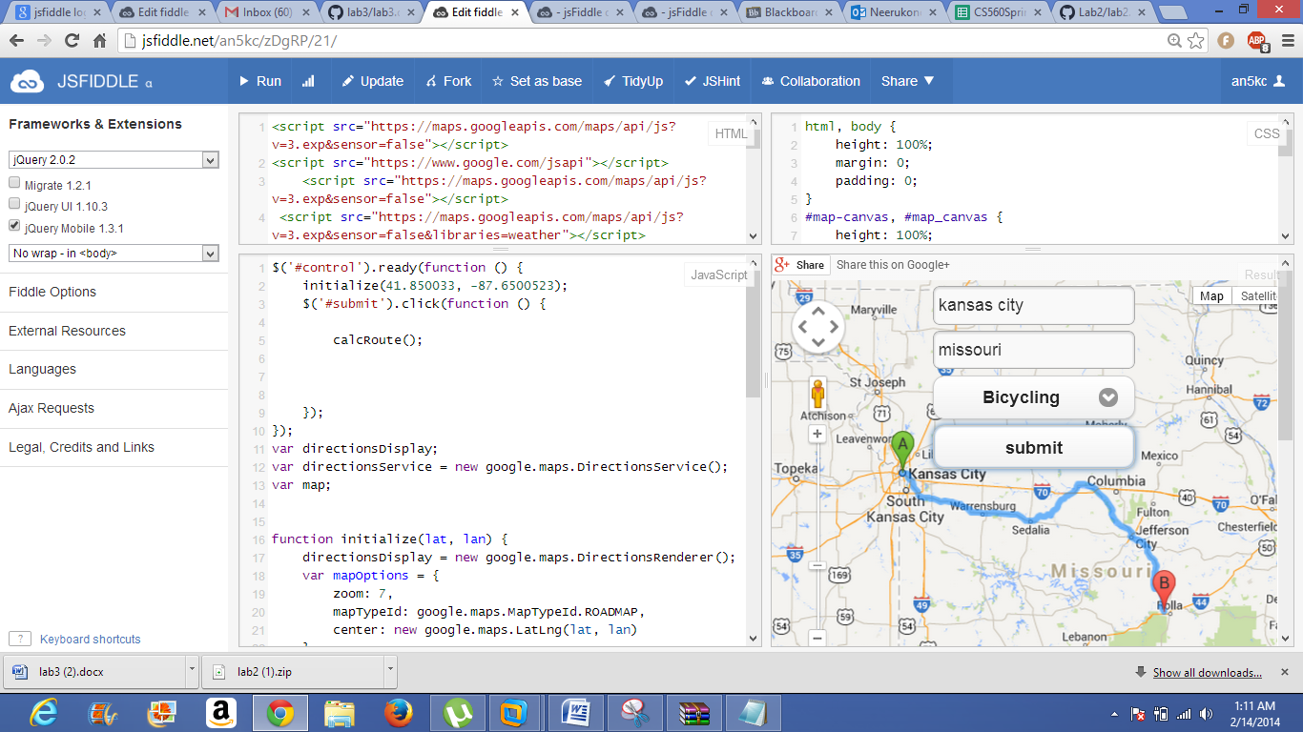

Here the user can share the application on gmail ,twitter and facebook and it is shown on below figure.

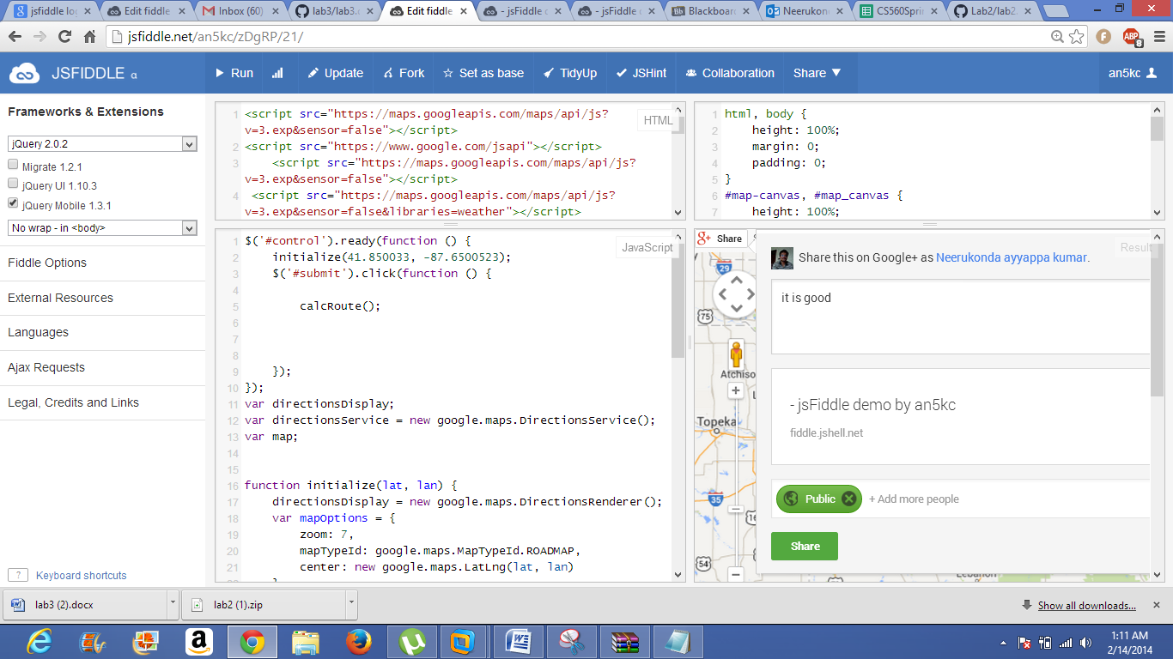

Application view on mobile.

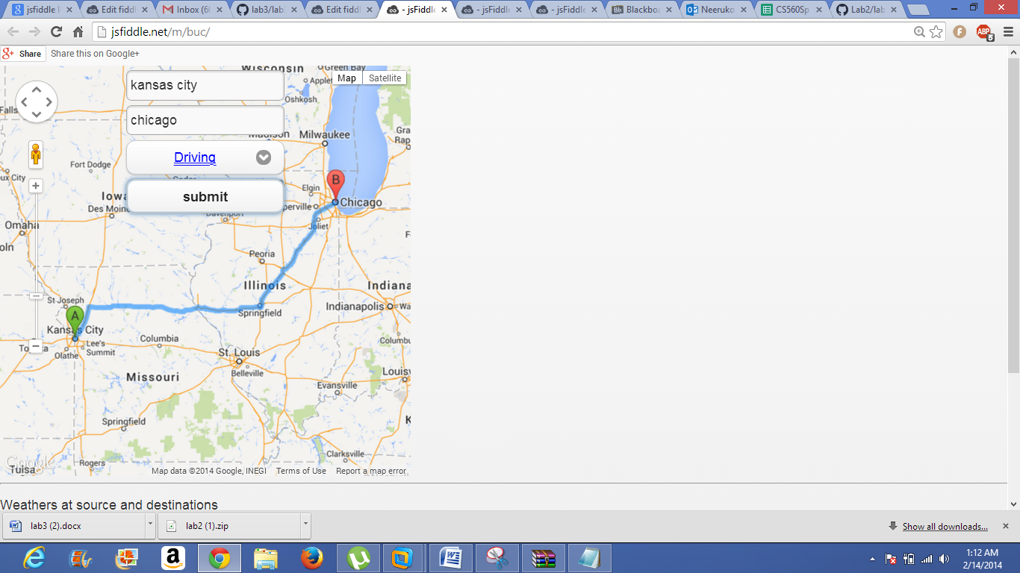

Here the temperatures of source and destination cities are also be provided.

